**Milestone Project 1**

**Question 1**

**Create a DB Schema for Hospital Management System.**

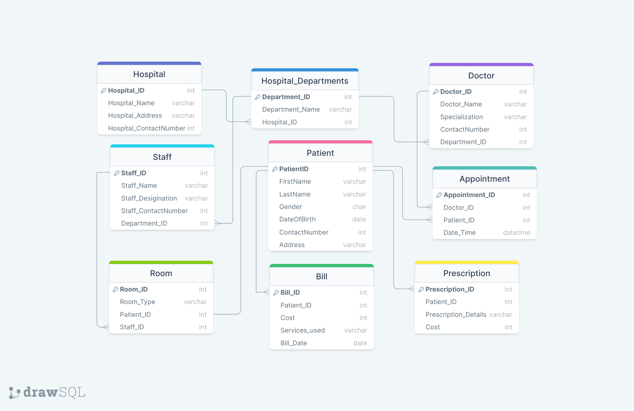

**Schema Representation of Hospital Management System**

**- >Write necessary queries to register new user roles and personas**

**Registering and Assigning Department to a Doctor :**

INSERT INTO `doctor` (`Doctor_ID`, `Doctor_Name`, `Specialization`, `ContactNumber`, `Department_ID`) VALUES ('7', 'Dr. Vikram Singhania', 'Cardiology', '997879882', '103')

**Registering a new Patient :**

INSERT INTO `patient` (`PatientID`, `FirstName`, `LastName`, `Gender`, `DateOfBirth`, `ContactNumber`, `Address`) VALUES ('11016', 'Arjun', 'Reddy', 'Male', '1998-01-21', '997879880', 'Thane');

**Registering and Assigning Department to a Staff :**

INSERT INTO `staff` (`Staff_ID`, `Staff_Name`, `Staff_Desigination`, `Staff_ContactNumber`, `Department_ID`, `Address`) VALUES ('202', 'Rajesh Kumar', 'Nurse', '89498185', '102', 'Thane');

**->Write necessary queries to add to the list of diagnosis of the patient tagged by date.**

**Adding Diagnosis Data related to Patient:**

INSERT INTO `diagonsis` (`Diagonsis_ID`, `Patient_ID`, `Description`, `Date`) VALUES ('404', '11016', 'Abdominal pain', '2024-01-26');

**List of Diagnosis of the Patients tagged by Date:**

SELECT d.Diagonsis_ID , p.*, d.Description, d.Date

FROM patient p

JOIN diagonsis d ON p.PatientID = d.Patient_ID

WHERE d.Date = '2024-01-26';

Output:

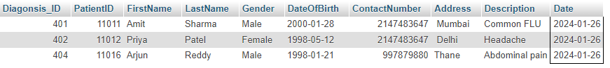

**->Write necessary queries to fetch required details of a particular patient.**

**Retriving Patients Data using Patient ID:**

SELECT * FROM patient WHERE patient.PatientID=11016;

Output : 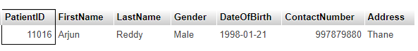

**Retriving Patients Data using Patient Name:**

SELECT * FROM patient WHERE patient.FirstName=”Vivek”;

Output: 

**Retriving Patients Diagnosis Data using Patient ID:**

SELECT p.*, d.Description FROM patient p

JOIN diagonsis d ON p.PatientID = d.Patient_ID

WHERE p.PatientID=11016;

Output: 

**Retriving Patients** **Prescription Data using Patient ID:**

SELECT p.*, pr.Prescription_Details,pr.Cost FROM patient p

JOIN prescription pr ON p.PatientID = pr.Patient_ID

WHERE p.PatientID=11011;

Output: 

**Retriving Doctors Data using Patient ID:**

SELECT p.PatientID,p.FirstName,p.LastName,p.Gender,d.Doctor_Name,d.Specialization

FROM patient p

JOIN doctor d ON p.Doctor_ID = d.Doctor_ID

WHERE p.Doctor_ID='2';

Output: 